**Premier Project Management Services/ Room Booking Project**

**Background:**

Premier Project Management Services is a large corporation with offices in several major cities around the globe such as Chicago, Orlando, Seattle, Denver, Boston, London, New Delhi, and Tokyo. There are a number of employees who frequently travel between office locations, working at one location for a week or two, before moving back to their home location or perhaps to another company location.

Each office location has several hundred employees laid out over several floors in an open floor plan (that is, most employees work in cubicles and only a few senior managers have dedicated office space). The company has been growing rapidly, and each floor is rather heavily packed with employees. Because the company has entered into long term leases with most of the building owners moving to more spacious quarters is not an option.

Although the working quarters are relatively tight, each floor does have several shared multi-use rooms. These include large conference rooms that can hold 12 to 15 people, midsize conference rooms that can hold between 6-12 individuals, and small conference rooms for up to 6 people. The company also has quite a number of “touch-down" spaces that offers privacy for one or two individuals and is primarily meant to be utilized by those visiting from other company offices. However, these touch-down spaces are often utilized by employees unhappy with their cubicle.

**Issue:**

The shared, multi-use rooms, whether they are conference rooms or touch-down spaces, are frequently utilized by many company employees throughout the day. So much so, that some teams often have a difficult time finding a conference room in which to hold an important team meetings at peak times. The situation has gotten so bad lately, that teams have had to cancel meeting due to the lack of available meeting space or meet off site which includes added time and expense. In addition, management has learned that many times, small groups of people, such as a group of three, are utilizing large conference rooms meant for 12 instead of the smaller, more size appropriate rooms.

Some locations have adopted their own method for reserving rooms. In some locations, there are teams of people who collect room reservation requests on an ongoing basis, and spend their days running between floors attaching “This room is reserved from x to x" on various conference room doors. This activity can take up to 20% of the working day.

**Proposed Solution:**

The project Sponsor Sally Frost (Chief Financial Officer) and James Harden (Facilities Director) have considered a wide variety of alternatives (such as telecommuting, virtual meetings, etc.) and decided that the best course of action is to implement a “room booking” application system that will streamline, standardize, and optimize room usage. This application will be a plugin on Microsoft Outlook’s scheduling application. Clicking on the plugin will bring you to screen that shows you all the conference rooms throughout the company (so that traveling employees can book space in advance) that are open or free at any particular time. Once implemented, this electronic room booking system will replace ad-hoc practices of people taping notes to the doors saying it is “reserved" or simply by grapping the first available room they see open regardless of size.

Sally has delegated all day-to-day authority of the project to James Harden. She just wants to be informed on the status of the project on a regular basis and only wants to become actively involved if a decision at her level is necessary.

**Additional details:**

Besides pre-booking rooms on the web, each conference room and shared space will have a panel monitor on the outside of the room. This room will have a visual display of the room availability schedule for the day (for example, booked 9am to 11am; open 11am to 12:30pm; booked 12:30pm to 3pm, etc.). The panel will display a green light if the room is currently not booked and a red light if it is currently booked. If the panel is green, someone passing by has the option to immediately occupy and book the room on the spot, simply by pushing a few buttons and entering in an employee pin number.

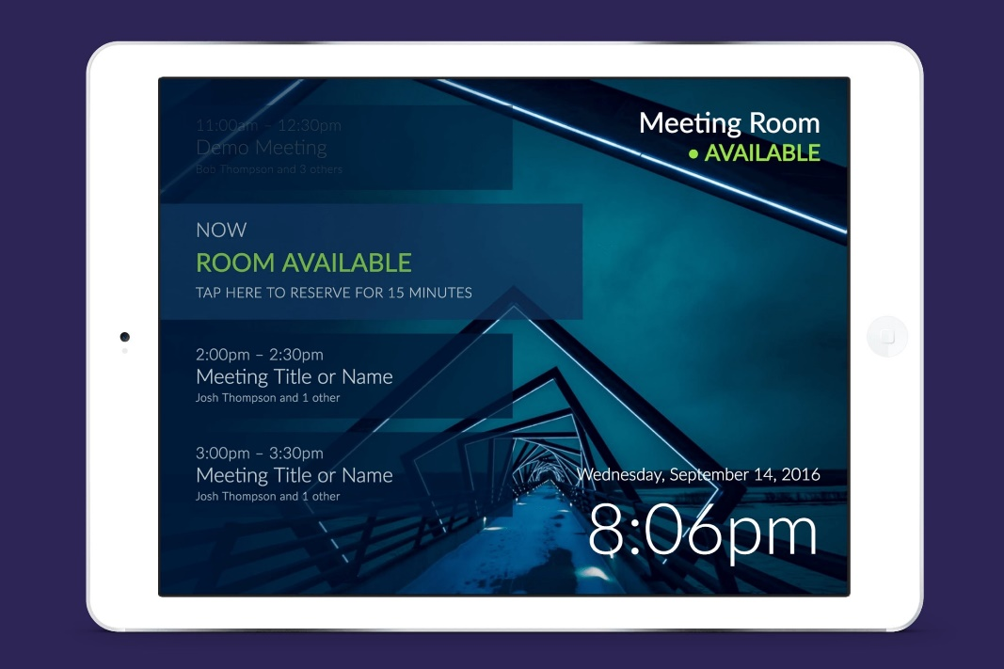

When a person arrives to occupy a room at the start of the scheduled time, the person who booked the room must “check in” to the room within the first 10 minutes of the scheduled start time. If not, the room reservation will cancel out and be shown to everyone as being “free” even if there are people currently residing in the room (because the person making the room booking did not “check in” or perhaps didn’t reserve in the first place).

The project manager will be Alice Jones. Her team includes a business analyst, MS Outlook Support engineers, a facilities subject matter expert, data base administrator (database will be Oracle), web developer, and a consultant from the vendor supplying the display panels. There will also be a facilities representative from each location that is assigned part time to the project to act as a subject matter expert. There will be other times when Alice (or the business analyst) has to engage other stakeholders when the need arises - ex. Legal, Information Security, to name a few.

The technology that is being utilized is proven and reliable but, like most technology, has some minor bugs in it. Some of the challenges the project manager will face is to first “catalog” all of the rooms (yes, ALL of the rooms) and put them into a searchable database. Other activities include procuring the display panels from the vendor, overseeing the installation of the display panels (outside of each room) by the vendor, coordinate training with the Human Resources department to ensure everyone is trained on the new system, and then making sure that people start utilizing the room booking tool so that benefits can be realized. It is hoped that employees will abandon their use of just grabbing rooms whenever they can, or reserving rooms the “old school” way by posting sticky notes.